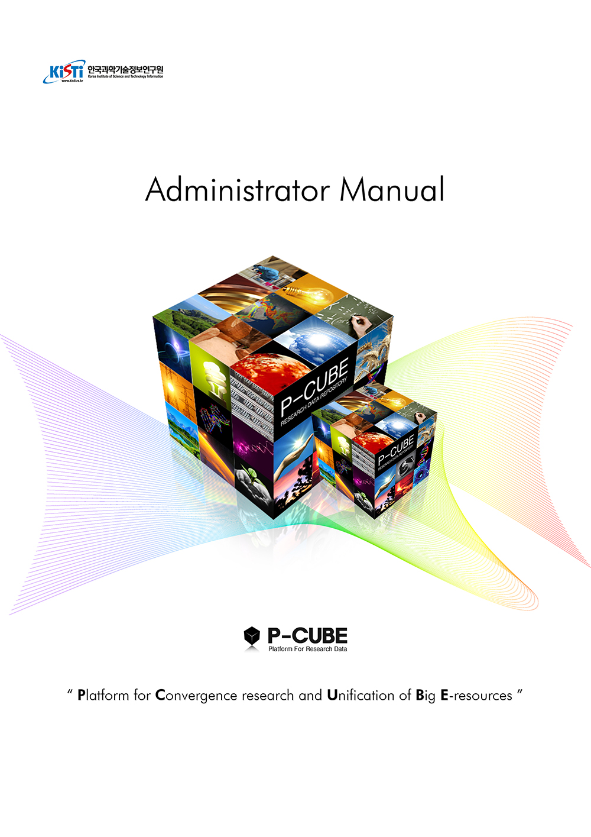

Table of Contents

**The comprehensive understanding of P-CUBE** 1

**Chapter 1 : Function of P-CUBE administrator** 4

**Account and Authority of Administrator** 4

**Chapter 2 : Schema management** 5

**Schema creation** 6

**Schema management** 10

**Chapter 3 : Organization & Collection management** 14

**Organization Creation** 14

**Organization Management** 16

**Creating collection** 18

**Collection Management** 23

**Chapter 4 : Item management** 29

**Item management** 29

**Management of a withdrew item** 34

**Chapter 5 : Importing items** 35

**Importing items** 35

**Chapter 6 : User Management** 37

**User Management** 37

**Chapter 7 : Group Management** 40

**Group Management** 40

**Chapter 8 : Statistics Management** 42

**Statistics Management** 42

**Chapter 9 : Code Management** 43

**Code Management** 43

**Chapter 10 : Notice Management** 46

**Notice Management** 46

**Chapter 11 : Environment Settings** 47

**Environment Settings** 47

**Chapter 12 : System monitoring** 49

**System monitoring** 49

**The comprehensive understanding of P-CUBE**

1. The understanding of item submission/verification process  
   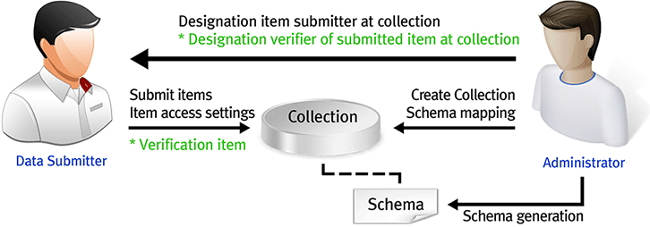

A data submitter submits an item.  
A user assigned as a data verifier verifies data of other users.  
Administrator creates a collection where the submitted items are managed.  
Administrator creates metadata of the submitted items.

1. The understanding of relations of schema and collection.  
   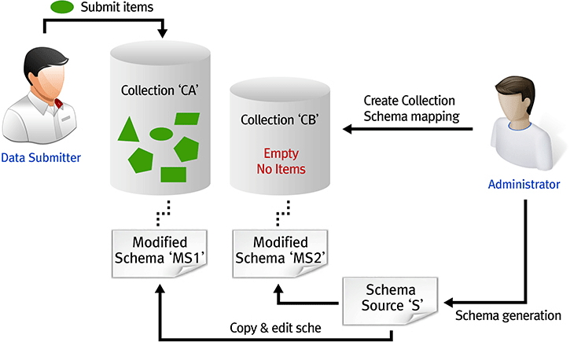

Original schema, 'S', connected to more than one collection can not be edited.  
Schema (MS1) of a collection where more than one items is submitted can not be edited.  
Schema (MS2) of a collection without items submitted can be edited.

1. P-CUBE data model  
   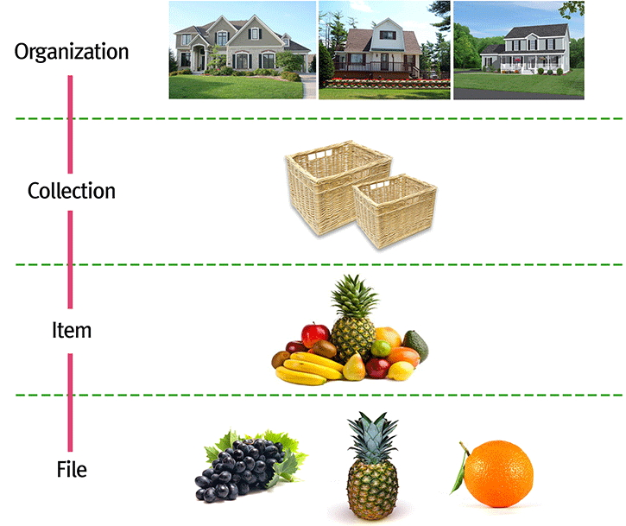
2. The understanding of item submission/verification authority  
   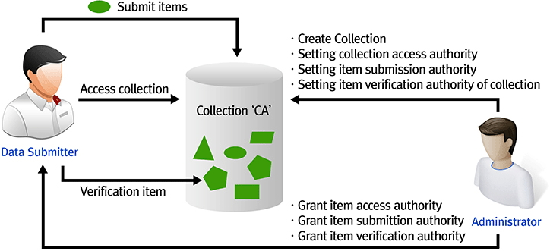

Administrator can assign the access of the related collection, submission of items, and the method of verification as creating collections.  
You can allow everyone to have access to search collection, or only certain users.  
You can allow everyone to submit items to collection, or only certain users.  
If the verification process of submitted item to collection is needed, you can include verification process, similar to the process of peer-review of thesis paper.  
If the verification process is not needed, items submitted to collection is disclosed to search service, right after the submission of an item is completed.

**Chapter 1 : Function of P-CUBE administrator**

**Account and Authority of Administrator**

**Administrator authority is needed to access the system of administrator.**

1. The image below is information of log-in, printed differently according to availability of administrator authority at user website. The left is administrator and the right one is user. Clicking "Go Admin Site" link which only shows to administrators, it will move to the main screen of administorator.

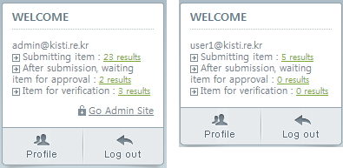

1. It is log-in information displayed at administrator screen, when you log in as an account with administrator authority. It will move to website of user, clicking "Go User Site" link.

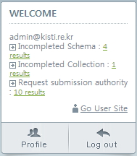

P-CUBE offers user system and administrator system as additional URL system.  
The link to move to adminstrator website is displayed only for those users who have administrator authority.  
You can assign administration authority other users through group management function.

**Chapter 2 : Schema management**

**A data submitter submits an item to the collection where the submission authority is assgined and information on item submitting, using the metadata field assigned to schema.**  
**Schema management which assigns fields to input when submitting an item is described below.**

**Schema creation**

**It provides function to create schema, a collection of structure of metadata and display settings.**  
**All collections have one schema.**

1. Click "Schema Management" on the left menu to move to management screen of schema.

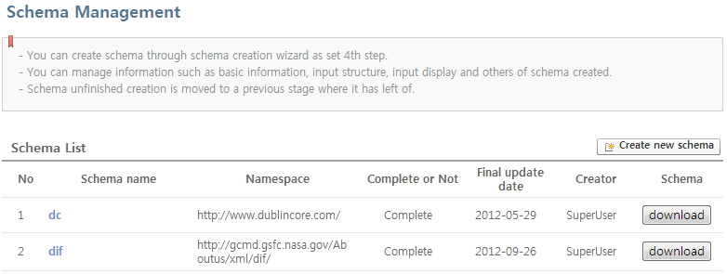

1. It will move to "basic information" input screen, clicking "New creation of schema" button.

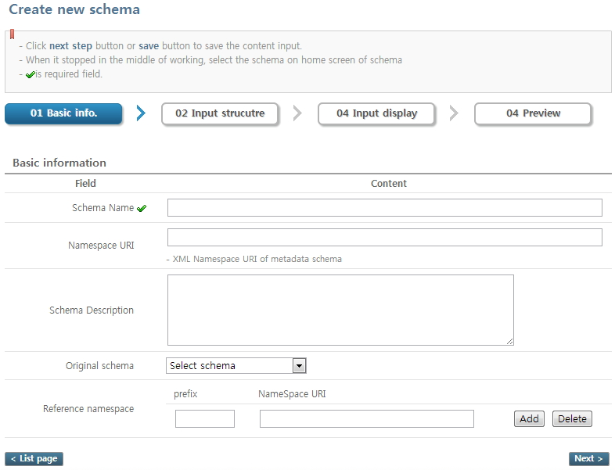

Schema name : name of title.  
Namespace : It is used for creating structure such xml, xsd file and etc, as namespace of schema.  
Schema descriptions : It is a description of Schema.  
Original schema : Select Schema for reference, creating elements of schema. Selected element of schema is applied to "input structure setting" stage.  
Reference namespace : It is used for creating structure of xml, csd file, as reference namespace of schema.

1. You can set element structure of schema on setting screen of input structure.

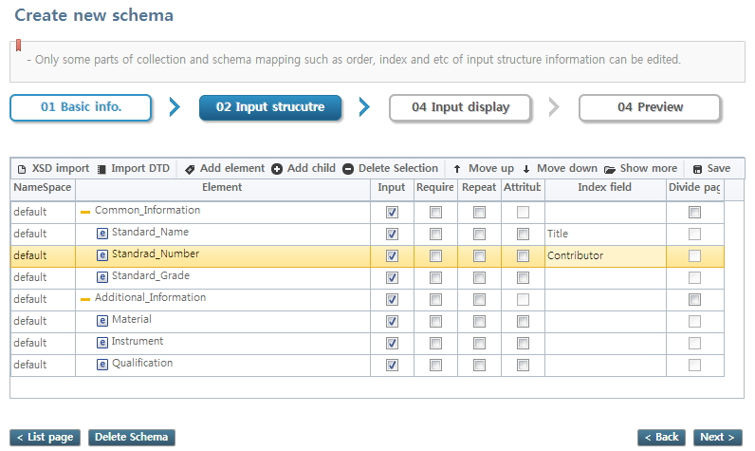

XSD Import : Importing element information using XSD file.  
DTD Import : Importing element information using DTD file.  
Add Factor : Adding element  
Add Children : Adding sub-element of selected element.  
Selective Deletion : Deleting selected element.  
Move Up : Changing the position upward. The position is changed by elements of same level.  
Move Down : Changing the position downward. The position is changed by elements of same level.  
Spread View: Showing all the element information including closed elements with spread view.  
Save : Saving the element information of current state.

Input : Setting whether to display element or not when inputting metadata in the step of item submitting.  
Necessariness : Setting for required input field, as inputting metadata in the step of item submitting.  
Repetition : Settings you can add and input element, as inputting metadata in the step of item submitting.  
Attribute : Displaying that it is a field corresponding with attribute of XML.  
Index Field : Indexing "Element" field with designated meaning to 'index field'.  
Page Division : The page of metadata input is divided by element displayed.

1. You can set names, and input formation of element displayed when inputting metadata in the state of item submitting stage on displaying input setting screen.

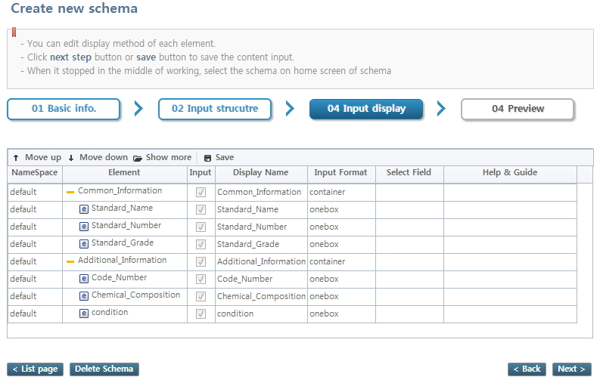

Field Display Name : Displayed as element name.  
Input Formation : Setting for input formation of element value.  
Selective Field : It is information of list displayed when the input formation is "dropdown".  
Help : It shows explanation on each element.

1. You can check information input during the schema creation stage on preview screen.

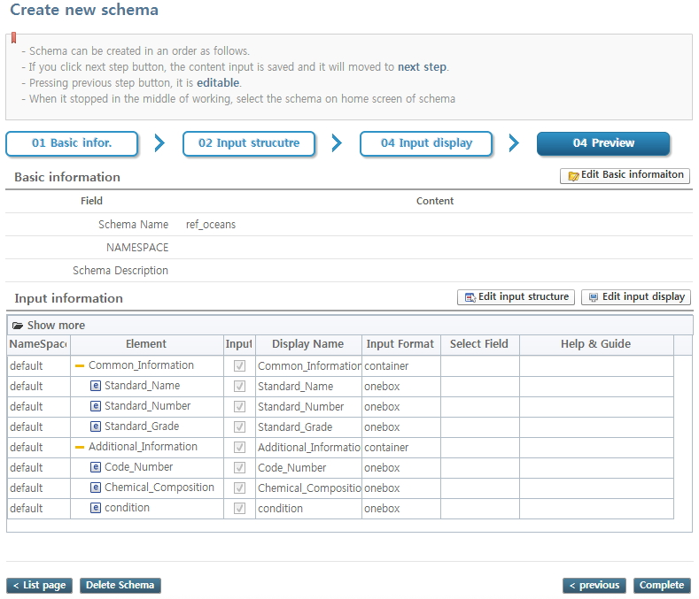

Schema creation will be completed by clicking "completion" button. And you can check schema created from the schema list.  
The uncompleted schema will be shown as "In the process of working" on the schema.

**Schema management**

**It supplies functions managing basic information, input structure, and display of schema nelwy created through new creation of schema.**  
**You can not edit input structure and display if there is a collection mappedwith schema.**

1. Click "Schema Management" on the left menu to move to management screen of schema.
2. Click completed schema from the list of schema to move to detailed screen of schema.

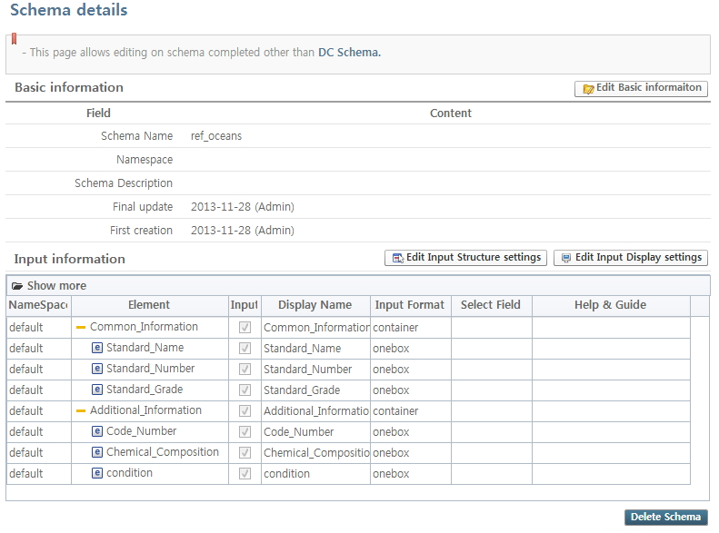

1. Click "edit basic information" button to move to basic edit screen and edit the basic information.

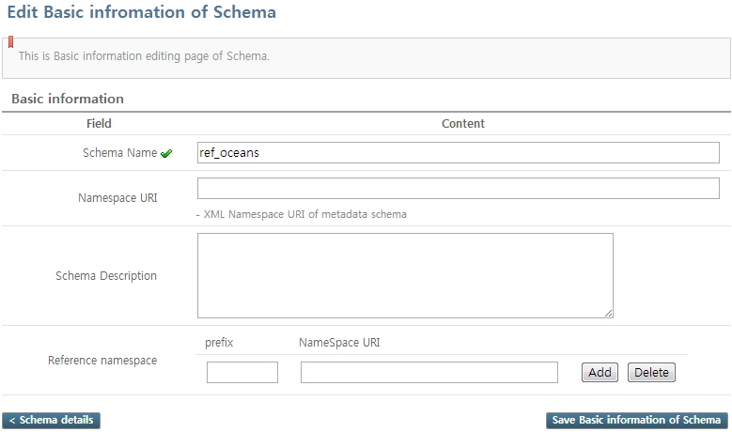

1. You can edit each field of element on "edit input structure".

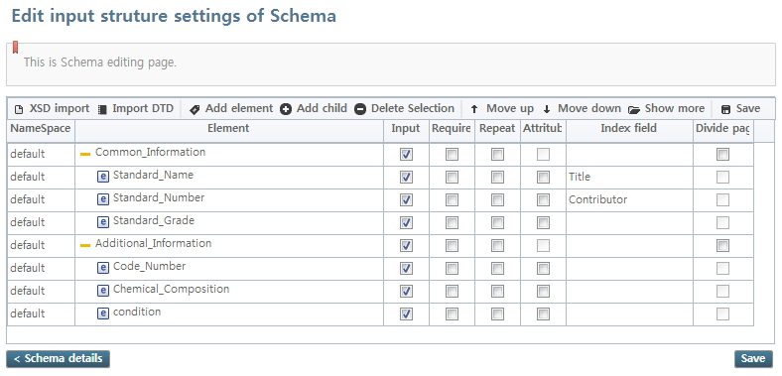

1. You can edit each field of element on "edit input display".

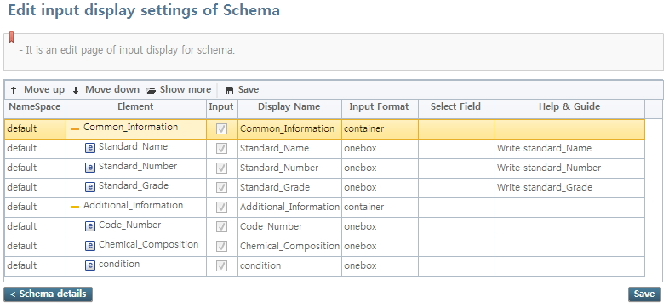

If it is created as above, it will show as belows on the item submission screen.

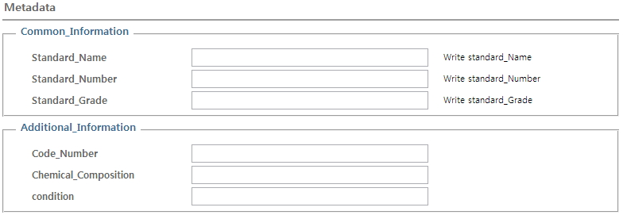

**Chapter 3 : Organization & Collection management**

**Organization can be both logical (virtual organization) and physical.**  
**You can create more than one organization, and one organization can get more than one collection.**

**Organization Creation**

**Organization is a group where collection is affiliated. The function of creating organization provides functions for creating new organization.**

1. You can check organization and collection list, clicking "organization and collection management" from the left menu.

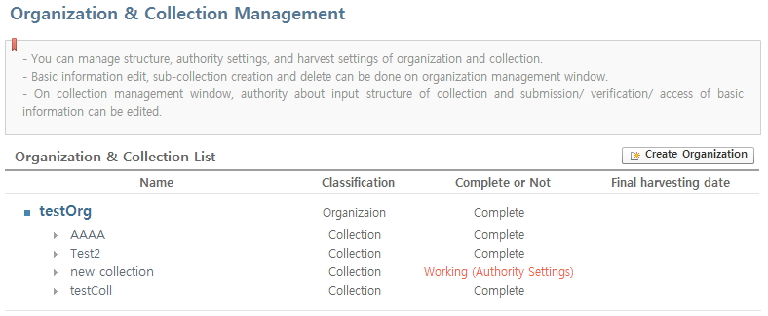

1. It will move to the "basic information" input screen of organization, clicking "Creating Organization" button.

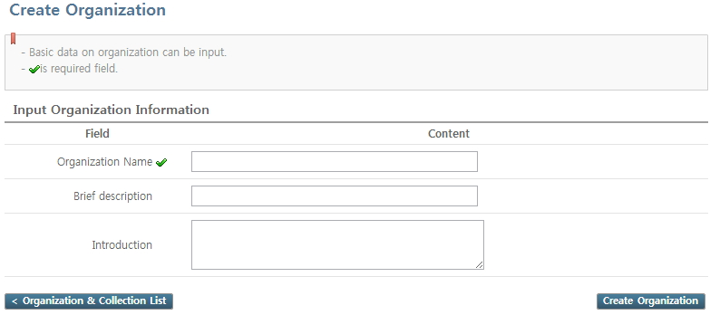

Organization name : Name of an organization.  
A brief account : It is a description for administrator.  
Introduction writing : It is a description of an organization for users.

1. You can check the created organization from the organization & collection list, after inputting and clicking "Creating Organization" button.

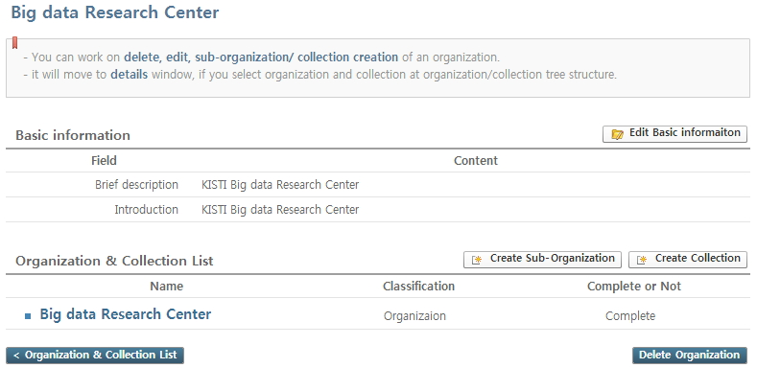

**Organization Management**

**It provides basic information editting of registered organization, and "create" and "delete" functions of sub-organization and collection on organization management screen.**

1. Clicking a certain organization from the "Organization & Collection Management" list, it will move to a detailed screen of organization.



1. You can edit the basic information of organization, clicking "edit basic information" button.
2. You can create sub-organization of the related organization, clicking "creating sub-organization" button.

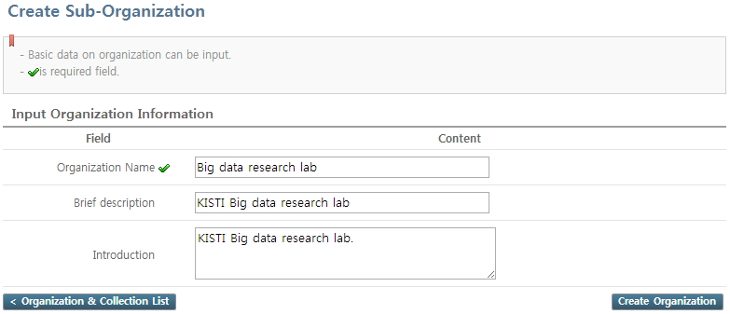

1. It will move to the screen of checking delete, clicking "delete organization" button. Click "delete" button to delete organization.

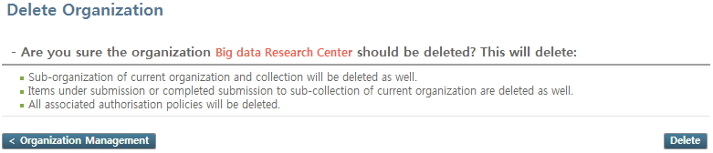

When deleting organization, all sub-organizations from organization, collections and items will be deleted.  
Also the information about authorities of access, submission, and verification will be deleted.

**Creating collection**

**You can use 'creating collection' function, in case of creating collection which is a basic unit for submitting and managing item is needed.**

1. It will move to "creation setting" stage, the first step for "creating collection" screen, if you click "creating collection" button on organization management screen.

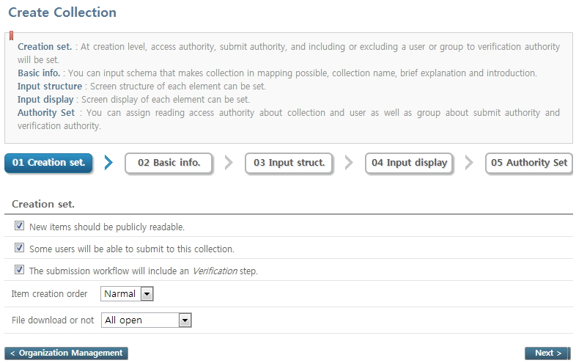

Access authority for reading : User or group who can access to submitted item to collection should be assigned at "Authority Setting" stage, if unchecked.   
Submission authority : You have to assign a user or a group submitting item to collection at "authority setting" stage if checked.   
Verification Authority : You have to assign a user or a group verifying an item submitted to collection at the"authority setting" stage, if checked.  
Order of creating item : The order of item submission stage is changed according to selection. "General" is 'metadata > file upload' and "File first" is File upload > metadata'.  
File Downloading or not : Selecting whether to allow downloading of an attached file on item.

1. Input the basic information on schema at the "basic information input" stage.

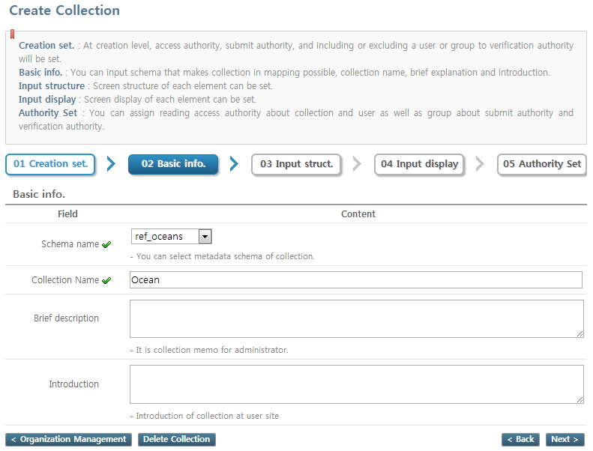

Schema Name : Select metadata schema of collection. Selected setting information reflects to collection that you wish to create.  
Brief explanation : A collection memo for administrator.  
Introduction : Introduction of collection that user can see.

1. You can edit based on settings for input structure of schema selected at " input structure setting" stage.

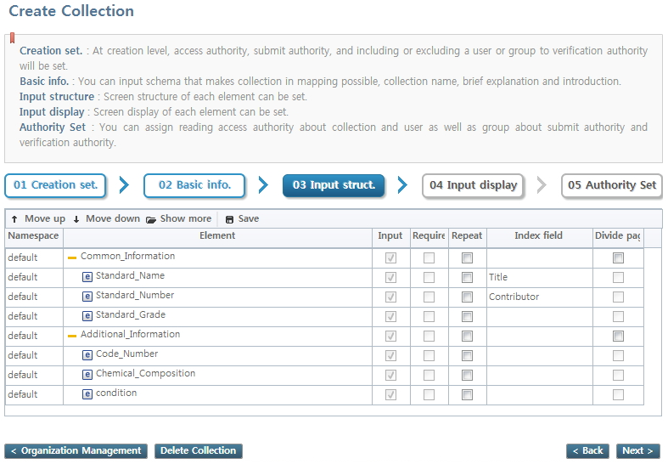

1. You can edit based on settings for input display of schema selected at " input display setting" stage.

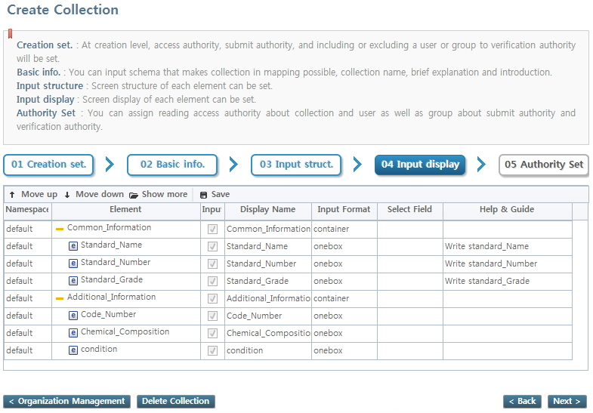

1. The stage will be displayed as checked at the "creation settings" stage, at the "author setting" stage.  
   If there is no more stages to set authority, It will display "Completion of creating collection".

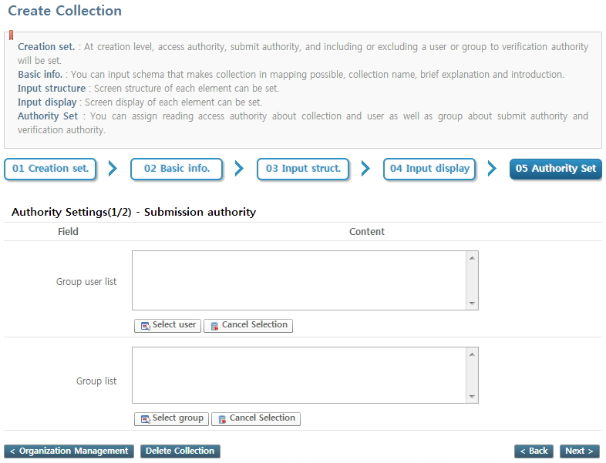

"Access Authority" : It assigns authority of reading items submitted to collection to users and groups.  
"Submission Authority" : It assigns authority of submitting items to collection to users and groups.  
"Verification Authority" : It assigns authority of approving the item completed submission to users and groups. Clicking "Completion of creating collection" button after selecting a verifier, the screen, selecting a representative verifier will be shown.

**Collection Management**

**Collection management function offers functions of 'edit' and delete' of collection registered.**

1. It will move to collection detailed screen as clicking certain collection from the organization & collection list.

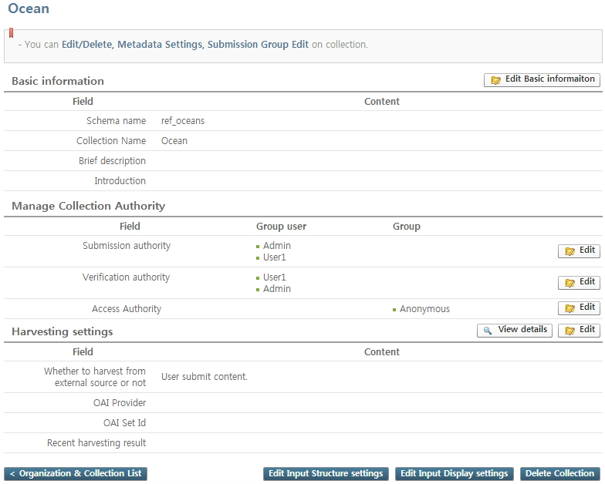

1. You can edit collection basic information as clicking "Edit basic information" from the collection detailed screen.

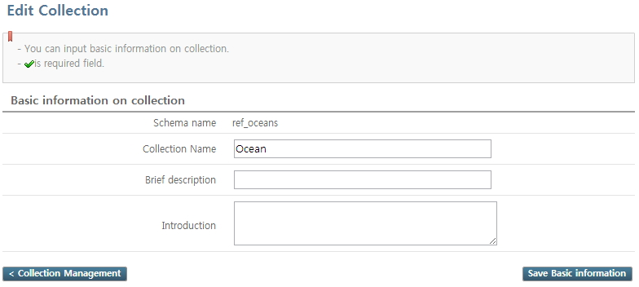

1. You can edit users and groups from the related authority, as clicking "edit" button on the right by each authority from collection detailed screen.

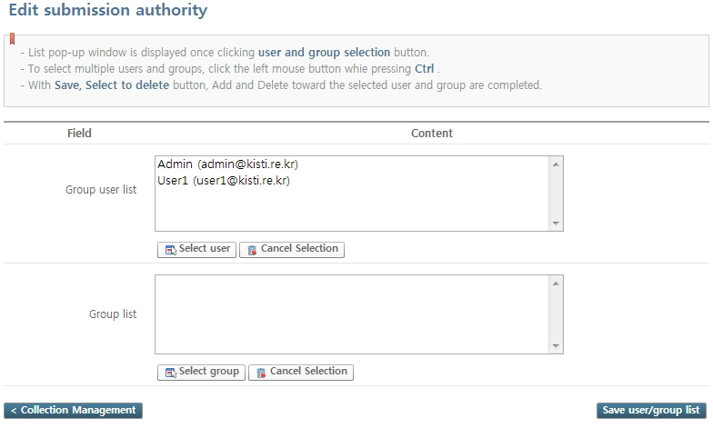

1. You can edit harvest setting, as clicking "edit" button of harvest setting from collection detailed screen.

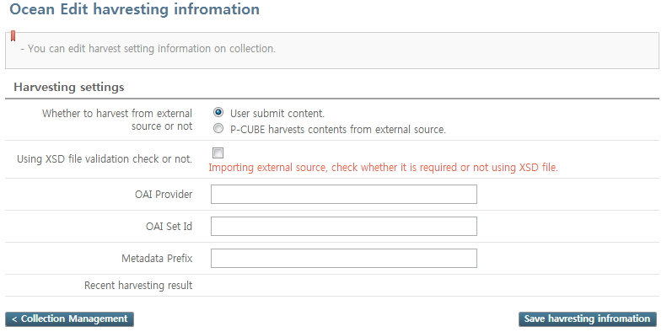

Input URL of Provider offering metadata with OAI-PMH into OAI Provider.  
Input Set offered at OAI Provider into OAI Setld. E.g.) all  
Input prefix value offered from OAI Provider into Metadata Prefix. E.g.) oai_dc, mets

1. You can check harvest history, as clicking "view details" button of harvest settings from the collection detailed screen. The information is saved only when the harvest setting is set as harvesting when the contents is from external source.

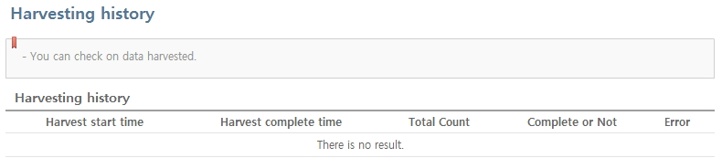

1. You can edit each field of element, as clicking "edit input structure" from the collection detailed screen. However, you can not edit when there is an item submitted to collection.

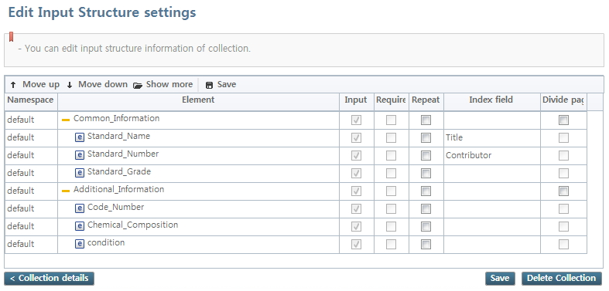

1. You can edit each filed of element, clicking "edit input display" from the collection detailed screen.

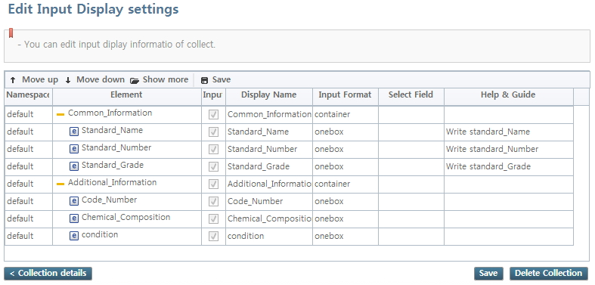

**Chapter 4 : Item management**

**Item management**

**Function of item management offers functions to 'manage' metadata and attached file on submitted item. Please use caution to 'edit' and 'delete', since the item is already submitted.**

1. You can check submitted item list, clicking "item management" menu from menu of the left screen.

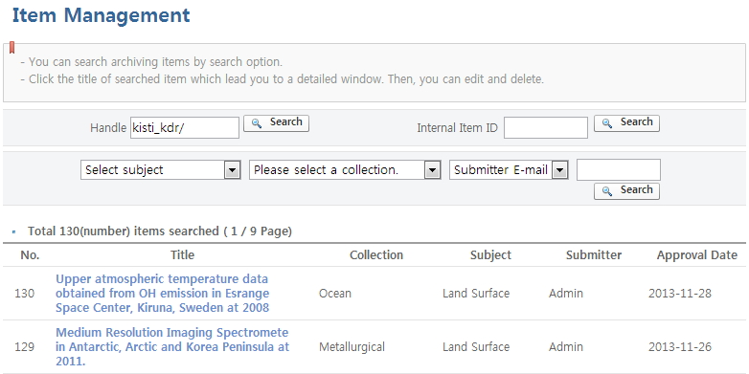

1. It will move to a detailed screen of item, clicking certain item from the list.

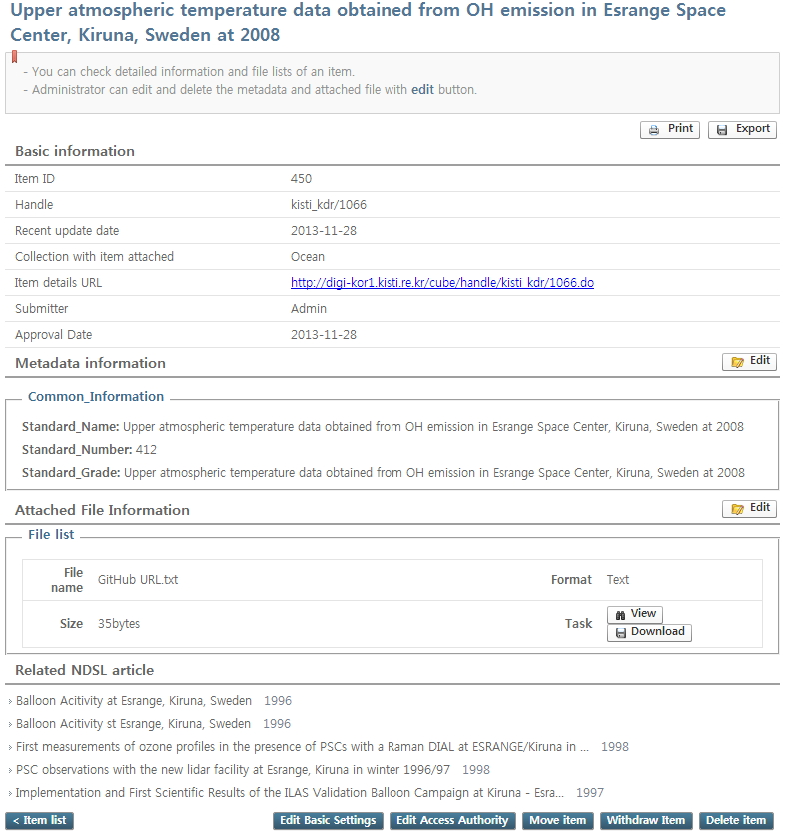

1. You can edit basic information of current item with "edit basic setting" from the detailed screen of item.

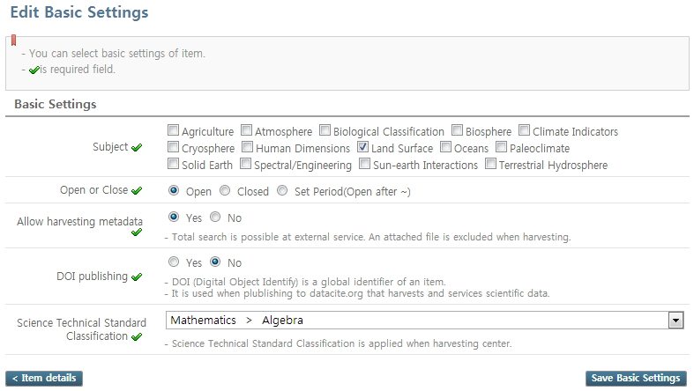

1. You can edit the access authority of current item with "Edit access authority" on detailed screen of item. Access authority is assigned with authority received from collection when creating item.

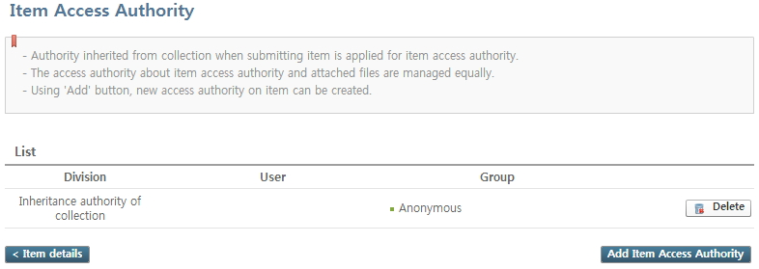

1. With "item move" button from the detailed screen of item, you can set selecting collection where current item to be moved to, and whether to applicate the authority of the collection to item.

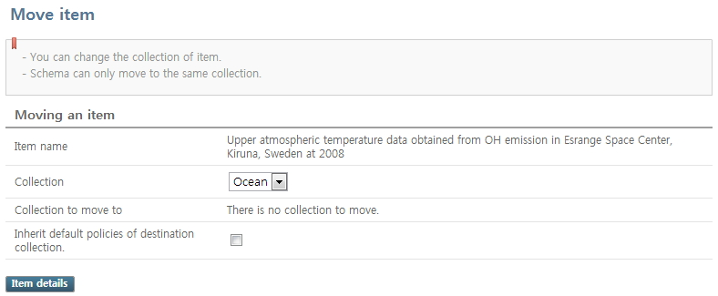

1. Change current item to the state of withdrawal through "item withdrawal" button on detailed screen of item, so that it will not be searched any more at user system.
2. You can print current item information with "Print" button on detailed screen of item, and save the basic information of current item as text or excel file with "export" button.

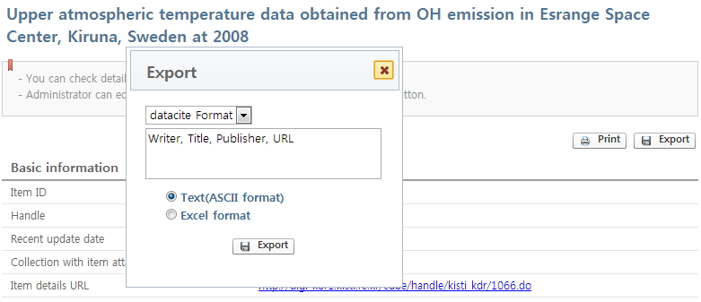

1. You can edit metadata information of current item with "edit" button of metadata information from the detailed screen of item.

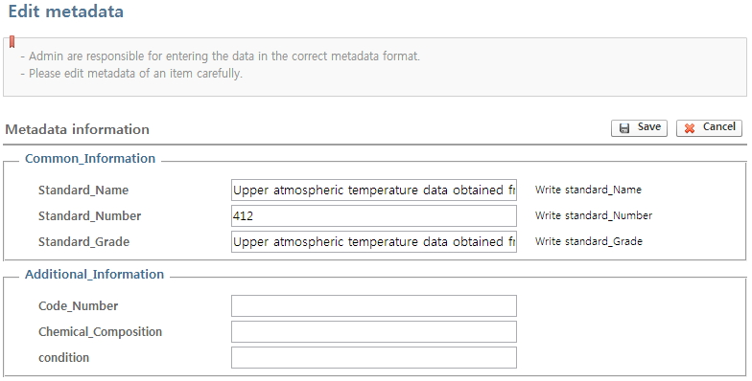

1. You can add or delete attached file of current item, clicking "edit" button from information of attached file on detailed screen of item.

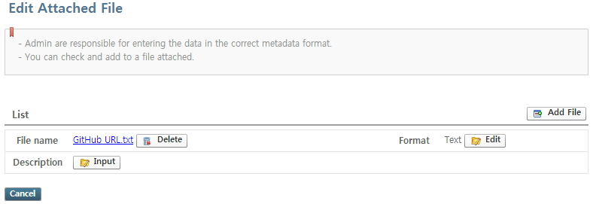

1. You can view files available for preview with "view" button of attached file on detailed screen of item.

**Management of a withdrew item**

**It offers functions of 'edit' and 'restoring submission status' of item withdrew.**

1. Search withdrew item list with "withdrew item management" button from the "item management" list below.

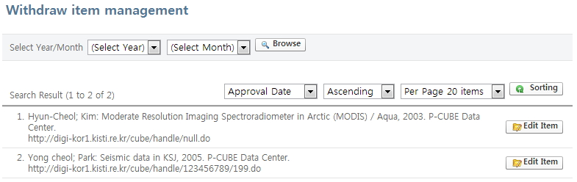

1. Move to metadata setting screen, clicking "item edit" button of item.

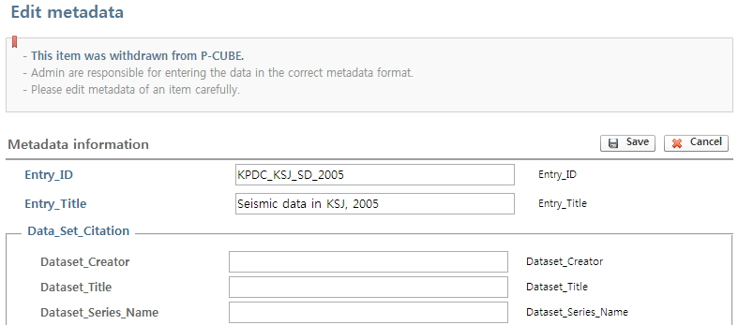

You can restore the status of item with "restore item".  
You can edit collection of current item with "move item" button. The state of submission is maintained as 'withdrawal' even the collection is moved.

**Chapter 5 : Importing items**

**Importing items**

**Imports information of metadata on several items written with excel file and saves as item.**

1. Clicking "importing item" menu on the left menu of the screen, it will move to item importing screen.

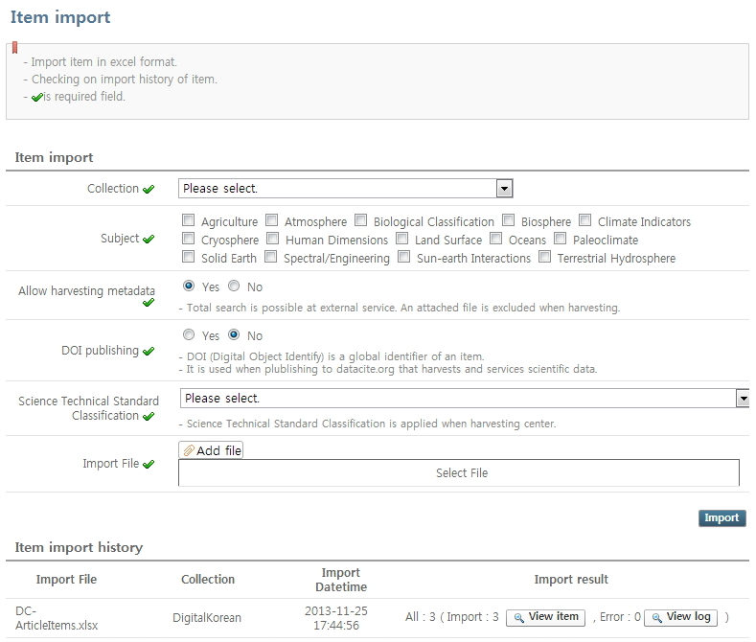

1. Select the import excel file with "find file" button of imported file after inputting input field of item import. Click "import task" button to import.

Setting information for importing is same as item import of user manual.  
The import content is displayed on the "item import history" list on the bottom of the screen after importing task.  
imported item can be checked with "View item" button, and items failed importing because of error can be checked with "view log"button.

**[Directions to an imported excel file]**  
The first row of excel file should include 'element name', and the sub-element should be input connecting after top element with '.'.  
E.g.) Case of 'description' for top element, and 'abstract' for sub-element : description.abstract  
Input metadata matched with the element name from the second line of the excel file.

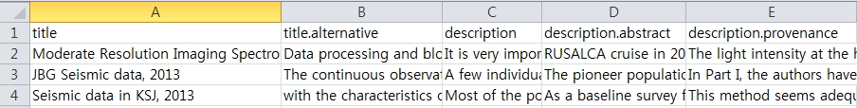

**Chapter 6 : User Management**

**User Management**

**It provides function to 'search' and 'edit basic information' on registered users.**

1. Click "User Management" menu on the left screen to move to user management screen.

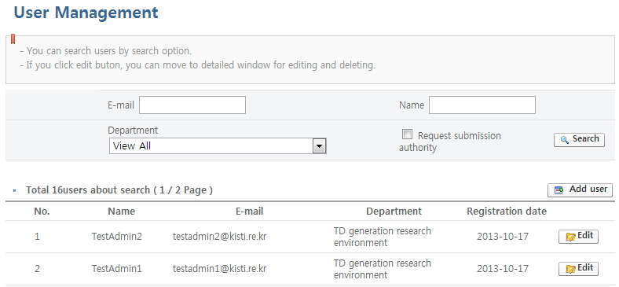

1. You can search users with conditions as 'e-mail', 'name', 'department', 'request for submission authority' and etc.
2. You make new user registration using "Add user" button.

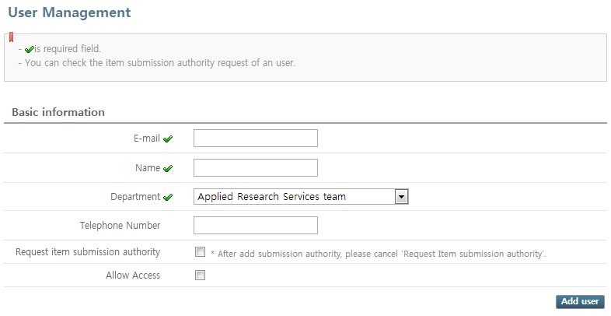

E-mail : An address for users to log-in or to receive an alarm.  
Name : name of a user.  
Department : Department of user. Affiliated department is managed at code management.  
Phone number : phone number of a user.  
Submission Authority Request Of Item : It will be selected if requested, when registering users as requesting item submission authority. Uncheck after assigning submission authority to users requested.  
Allowing access : Selecting possibility of user log in. If unchecked, login of user is not allowed.  
* Password of a user is applied to id part of user e-mail, when adding a user.  
* E.g.) The password would be 'user1' for user1@gmail.com

1. You can edit and delete by users, clicking "edit" button on the right of user list.

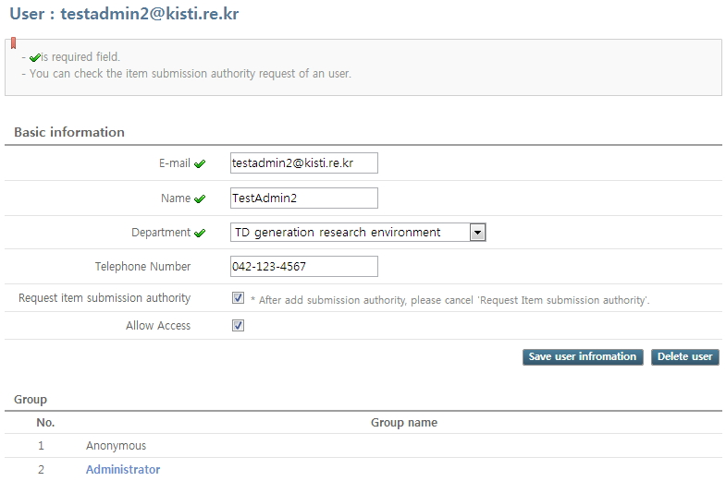

**Chapter 7 : Group Management**

**Group Management**

**You can manage a group where user belongs to. All the users from the group receive all authorities, with giving certain authorities to groups.**

1. Click "group management" menu to move to group management screen from the left menu of the screen.

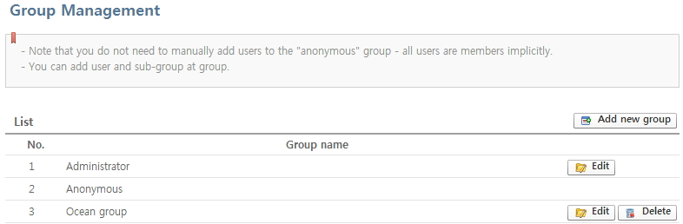

1. Create group, clicking "add new group" button.

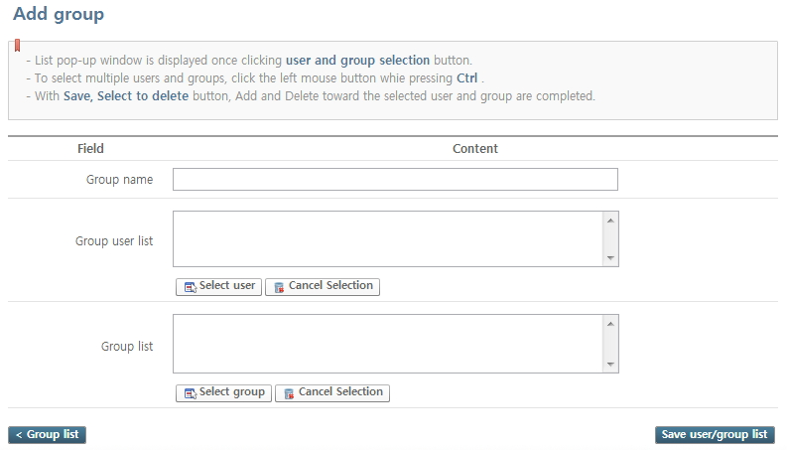

1. You can edit groups by clicking "edit" button on the left side of goup.

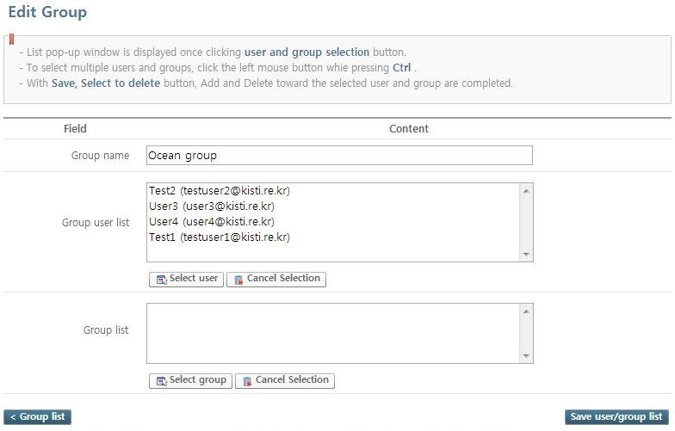

'Administrator' group is a group of administrator.

1. You can delete group, clicking "delete" button from the right of group. The information on user will not be deleted even if you delete a group.

**Chapter 8 : Statistics Management**

**Statistics Management**

**Status of item submission and user access can be checked with graph and figure.**

1. Move to statistics screen with clicking "statistics management" menu on the left of the screen.

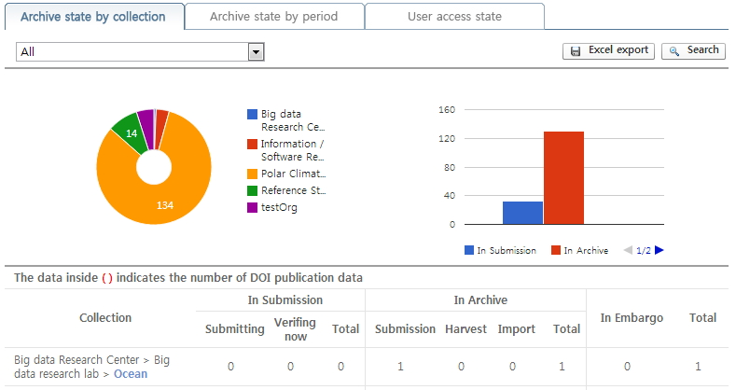

'Archive state by collection' tab checks status of item submission and the number of item submitted by collection.  
'Archive state by period' tab checks the number of items built by period.  
'User access state' tab checks the number of user accessed by period.

**Chapter 9 : Code Management**

**Code Management**

**You can manage codes used for P-CUBE such as item submission, and user registration.**

1. Click "code management" menu on the left of the page to move to a code management screen.

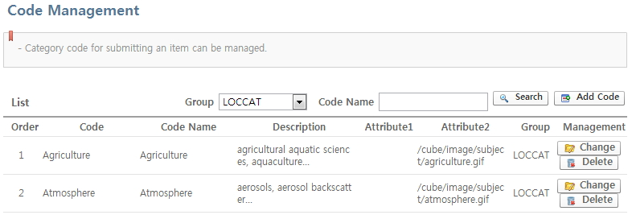

1. You can search by code group, and code name.
2. You can create new code, using "add code" button.

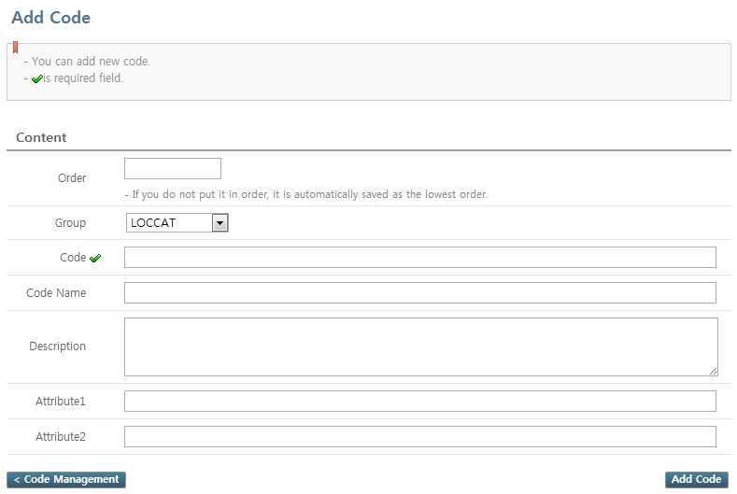

Order : It shows order of alignment for code in groups.  
Group : Code group can be selected.  
Code : It is a unique value of a code used internally.  
Code name : It is a name of code on screen.  
Explanation : It is an explanation on code.  
Property 1, property 2 : Inputting an additional property of code. Inputting image route into property 2 is necessary, especially when it is a case of subject classification.

Adding code group has to edit DBMS directly, so please contact to developer of the related institute to add.

1. You can edit code with "Change" button on the right of the code.
2. You can delete code with "delete" button on the right of the code.

**Chapter 10 : Notice Management**

**Notice Management**

**You can 'write' or 'edit' a notice announced on the main screen.**

1. Move to notice management screen, clicking "Notice management"on the right of the screen.

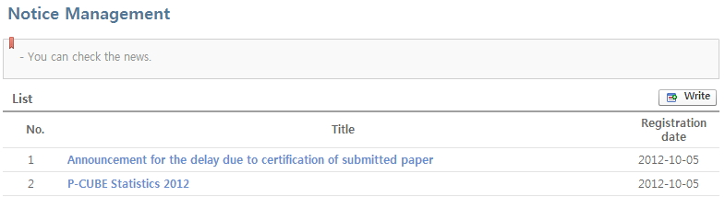

1. You can write a new notice, using "write" button.

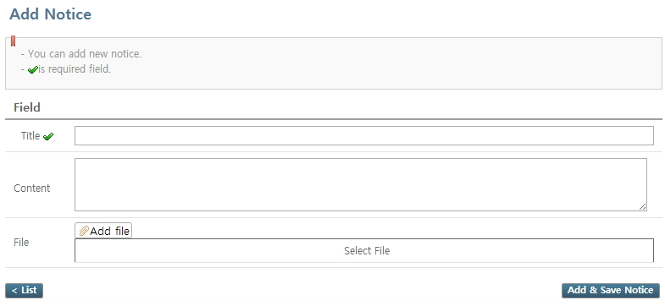

Title : The title of notice.  
Content : Detailed content of notice.  
File : Attached file added to notice.

1. You can check the notice written, clicking notice'.

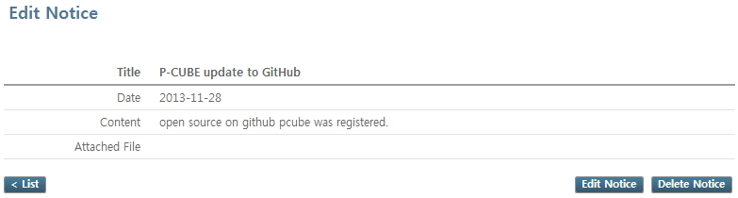

1. You can edit the notice using "notice edit" button at the detailed screen of notice, and delete the notice with "notice delete" button.

**Chapter 11 : Environment Settings**

**Environment Settings**

**You can edit the veriable on basic settings of website.**

1. Move to environment setting screen by clicking "Environment Setting" menu on the left screen.

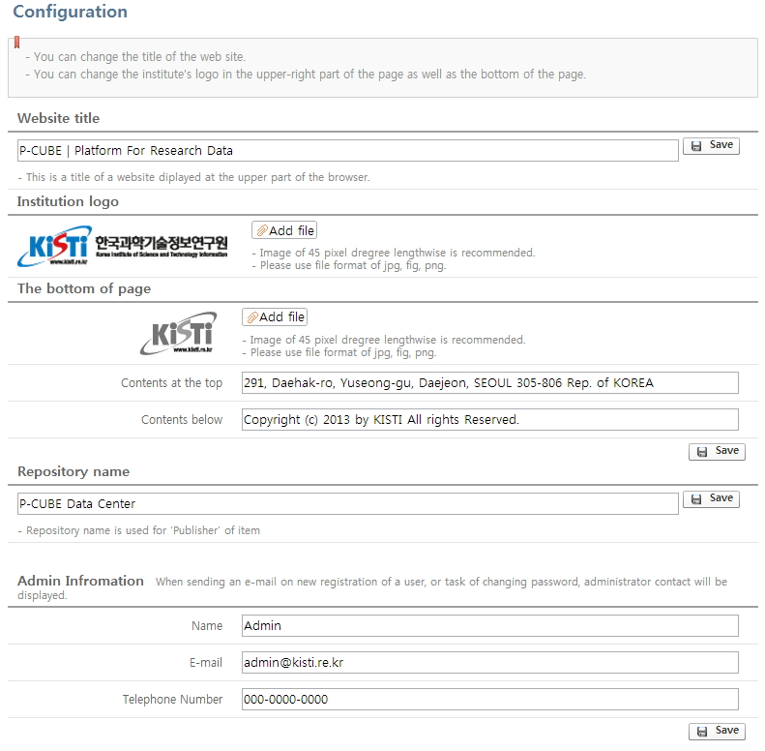

Name of website : Title shown at the tab of web browser.  
Institute Logo : Logo of institute or department placed at the upper right of the screen.  
the bottom of the page  
- Image File : File logo displayed on the bottom of the page.  
- Content above : Information to be displayed in the first line among information on the bottom of the page. E.g.) Institution address  
- Content below : Information to be displayed in the second line among information on the bottom of the page. E.g.) copyright  
Repository Name : Use for 'Publisher' metadata when submitting an item.  
Administrator Information  
- Name : name of a user.  
- E-mail : E-mail of a system administrator.  
- Phone number : phone number of a system administrator.

**Chapter 12 : System monitoring**

**System monitoring**

**It provides information on checking state information periodically such as CPU, Memory, and Storage of installed server where P-CUBE is installed.**

1. Move to system monitoring screen by clicking "system monitoring" menu on the left window.

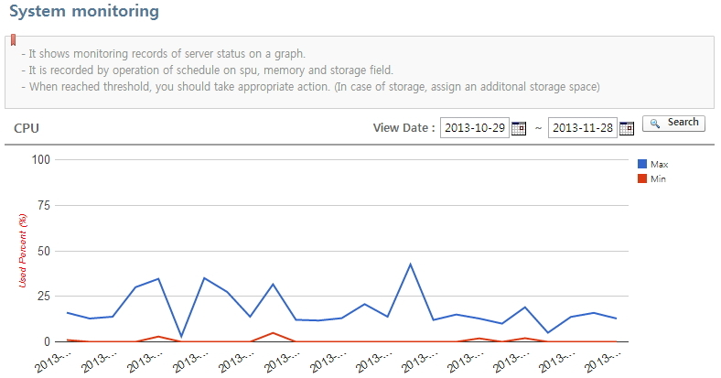

It would not be used depending on the settings of cube.cfg. (It is described at developer manual as setting file of P-CUBE.)  
You can search with search date by period. (Case of storage, search with month)  
Put mouse cursor on graph, the related date and data will be displayed. Data by inspection period with clicking.  
If it reaches risk figure with setting of cube.cfg, an alarm e-mail can be sent to e-mail of administrator.